**Week 5: Asynchronous Design Studio**

3D printed community project

Modelling and Simulation

**Step 1 – Overview**

Review this introduction to modelling, watch the modeling video [5-Design Studio →Week 5 → Wk-5 - Modeling Video - 3D Housing], then follow the activities further down in this document. Please see 3D House Sample Model on Avenue under [4-Project Modules → 3D Printed Housing]

**The engineering model**

One of the most powerful techniques that engineers have developed to manage complex design projects are engineering models. Models blend mathematics, science, and computing to produce software tools that help engineers predict important design considerations. You have already encountered engineering models in CAD software, virtual twin simulations, and many algorithms and equations that you have encountered in various courses. All of these are elements of modeling tools to help us predict design outcomes. The one common element of all models is the fact that they offer ways to test different design parameter configurations without a fully developed physical prototype.

**Modelling for the 3D Printed House Project**

Many things in this complex project can be modeled. Structural performance of walls, the overall cost of the project, power consumption by a completed neighbourhood once residents move in, potential traffic patterns in a developed community, and many more can relate to mathematical representations and then transferred to convenient computing tools. For 2PX3, you will work principally with an Engineering Project model.

Modeling of project throughput. In particular, given the choice of a particular housing mix, choice of material, and whether we build on-site or in a factory and ship pieces to the build side, how much time will it take to print and secure all of the houses in the desired development. A sample model will be provided in spreadsheet form which is a very common tool for estimating key variables for complex projects that depend on a broad range of very different and sometimes, uncertain factors. Groups will use and enhance the sample model to perform their modeling analysis. Additionally, an introductory video is provided that explains the thinking and structure of the model.

**Approximations and Assumptions**

Most models that engineers use will embody many approximations and assumptions. They are not perfect. If you are using Newton’s kinematic formulas to predict the distance that a ball will travel if you throw it at a certain initial velocity, its predictions may be correct enough for most cases, but it may not have the mathematical terms required if the ball was being thrown outside into a very strong headwind. If that were the case, a good model would have additional terms to account for these other factors. However, if you know that you will always be inside or if the desired accuracy can tolerate being off by a meter or so, the model, even with its deficiency, may still be useful and good enough.

The models that you will work with for this project embody many assumptions to make the calculation manageable. In a real construction product, you have countless factors that can that you can account for but is it necessary? For example you could estimate the time it takes for materials to go from storage to build site, or begin accounting for time taken by workers on breaks, etc. but if the goal is to get a good estimate of total project time which will likely be several weeks or months, getting too granular in your modeling does not help get any better answers and you would expend enormous energy to build and debug your model.

Project modeling especially is a case where engineers use generous assumptions because so many things impact the time and it is often more productive to use a reasonable conservative assumption that could account variability in the elements. For example, there may be many things that could slow the transport of a printed room to the build site but it really makes no practical difference if the actual time is 9 hours compared to 14 hours. Most engineers would simply estimate this to one day unless the heavy trucks will be moving non-stop for many days which is typically not permitted in communities.

The sample model you have has many such broad assumptions. You are not bound to any of them. They are provided as a starting point. You are encouraged to add factors and considerations.

**Step 2 – Using and adjusting the model**

*This step assumes that you are comfortable with spreadsheets and the basic outline of the sample model as described in the video. If you are not comfortable, there is additional information on the sample model following this step. If you are very new to spreadsheets, there are many tutorials you can access on line. This one,* [*Excel Training for Engineers*](https://www.youtube.com/watch?v=_H8jdh-yHCc) *shows spreadsheet use for engineering applications as opposed to financial applications.*

Review the model by stepping through the key cells and reviewing their labels and any comments. Review the predicted project time and make sure you understand the steps it took to calculate the value.

*Scenario 1*: Some stakeholder research has shown that the likely residents would prefer more open concept interior layout. As an initial estimate, you have deduced that a simple adjustment to a lower value of the parameter “Interior wall total length” will be good enough for a first estimate.

The resulting predicted “Print time in hours” is 7.1 .

What do you think the corresponding “Print time in days” should be? 1 .

What assumptions did you make to deduce Print time in days?

I assumed an 8 hour workday when making this deduction. Since 7.1 hours falls within an 8 hour workday, it would only take one day to print the house.

*Scenario 2:*You have been told that after 1 meter of print height, a live inspection is required and this step typically takes 2 hours. How would you adjust the model?

Assuming the inspection takes 2 hours per meter, I would maximize the print height at 4 metres, so that the inspection can be done in a day. Or, if there are multiple stories on the house, I would make each wall 3 metres, since it is going to be take 2 days anyway and (approximately) 3 metres is the standard wall height in Canada.

In the sample model the deduction of “Print time in hours” to “Print time in days” is actually a human step. The user assesses the value in hours then using common sense, rounds up the value to a full day. Can you think of a logic that can be implemented in a spreadsheet that may automate this step so that the Print time in days automatically calculates?

Using the CEILING.MATH() function in excel, we can determine how many days will be needed assuming a workday is 8 hours. This can be accomplished by dividing the print time in hours by 8, and rounding up to the nearest integer number, which is structured as CEILING.MATH( {Print time in hours}/8 ) in excel. For example, a print time in hours of 7.1 would result in a print time in days of 1, while a print time of 9 hours would result in a print time in days of 2.

Scenario 3: A supplier has advised you that the material cost may increase significantly soon. Currently the sample model calculates print time. How would you modify the model so that you can also compute the amount or volume of material used?

Knowing the nozzle has a diameter of 40 mm and nominal print speed, we can create a formula to calculate the volume of filament outputted per second.

The above equation was derived using the information currently in the spreadsheet. Below is a general formula:

**Step 3 – Initial consideration of PERFORMANCE**

For the PERFORMANCE stage of PERSEID, weather performance and print throughput were provided as key consideration for design. Your team then did initial brainstorming to consider possible options. Now that you have the model at your disposal, how do you think you can proceed to make good decisions for the PERFORMANCE elements?

What do you think the word “Throughput” can encompass? How would you define it to help you organize your design decision making process?

I think throughput encompasses time-related performance elements of the PERSEID process. Throughput is primarily associated with printing throughput, as in the nominal print speed and the material output per unit time. These are mainly discussed when concerning the time constraints of a construction project. Throughput can also include the cost/time of transport and manufacturing, as well as labour.

Similarly how would you define “Weather performance”?

Some performance elements that can be defined under weather performance include structural integrity, as in the strength of the building as a whole. Also, waterproofing properties of the chosen material, rigidity of the chosen material, waterproofing properties of the printer, fracture stress of a material, malleability, thermal and insulator properties. As can be observed, most of the properties falling under weather performance are pertinent to the material properties of the printer filament.

Which design options and considerations are well represented by the model (including any changes that you think you can make)?

The model represents well the print time in proportion to the size of the house and the resultant time needed to accomplish the project. However, I think that the print time in days can be easily automatically calculated, as well as a few other time-related parameters.

Which design options and considerations are not well treated even with modifications. In that case, how should your team get to a good decision?

I think that the model can better represent material used relative to time, costs relative to time (labour, electricity), and defining the limits of a project with a budget.

**Details of the sample spreadsheet model**

All of the following are covered in the video but you may find this written version as a helpful reference.

Spreadsheets are a standard tool for organizing large amounts of calculations that depend on each other. Perhaps the most common use of spreadsheets are for financial calculations such as budgets, but any application where one calculation is derived via a formula from parameter values or other formulas can very quickly developed on a spreadsheet. For this project, the spreadsheet model is used to associate key calculations and provide convenient ways to enter and change parameters. However, spreadsheets have natural limits as everything is constrained to a table formats and very simple algebraic formulas.

Review the MS Excel spreadsheet file. There are two tabs that correspond to two separate models. The basic question we want the models to answer is “how long will the building of the core printed structure take for all houses in the development?”. Furthermore, we want to compare the potential project times between shipping the printer to the build site and printing directly on the lot versus printing the main elements in a factory then shipping these prefabricated (prefab) components to the site.

**On-site printing option (*On-site* tab in spreadsheet)**

The following are the modelling steps for the on-site. The rows of the spreadsheet roughly correspond to these steps. Comments are included in the spreadsheet. The following are general comments to provide insight into the scope and assumptions made.

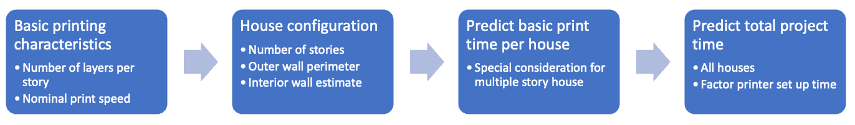

One of the more fundamental assumptions that we make in this model is the way we calculate the total linear length of all walls. In a real application, the engineering team would extract this information from a CAD software model. But this project represents an initial exploration for the design of the houses and consequently, a broad range of assumptions can be made to simplify the initial assessments.

For the on-site model, we consider two typical house layouts that are common in Canada: a single-story house roughly 12m x 13m and a two story house with a 7m x 12m footprint. These house choices were inspired by actual Canadian house plans available from Beaver Homes to define the basic outer dimensions and get a rough estimate of interior wall lengths.

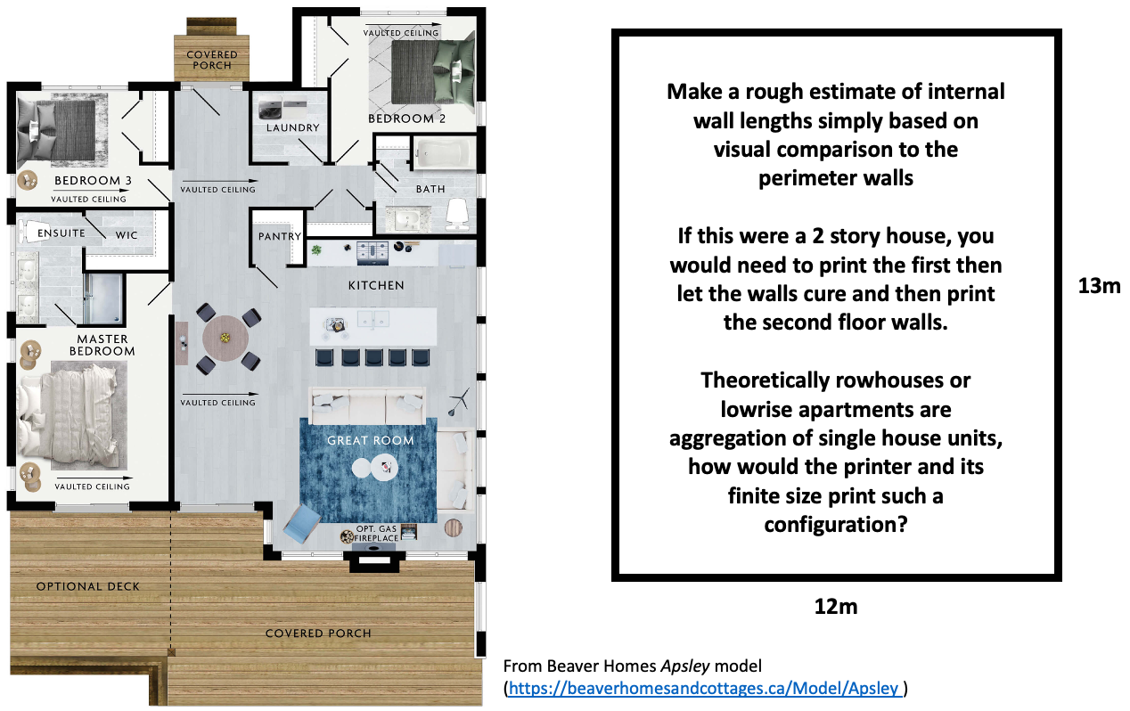

The prediction of print times for a single story house is straight forward as it is assumed that a wall of height 3m and all its layers can be printed without pausing for material to cure mid-height. Additionally, it is assumed that there is no difference between the speed of movement of the print head when it is actually extruding material or if it has stopped because of a window or door opening in a layer – i.e. the head will always be moving at the same speed whether it is depositing material or not. For the two story option, a parameter is introduced to model a curing process after the first floor is completed. This will allow the second floor and its associated weight to be printed on a more stable first floor structure.

**Prefab printing option**

This option assumes that the house or portions of the house can be printed in a weather-tight, controlled environment, indoor space away from the build site. But it would be easier to engage multiple simultaneous printers and extended operational hours thus potentially increasing throughput significantly. However, there would be a time penalty in transporting the printed elements that are literally house-size and then securing the elements on the build site.

Additionally, if the footprint of the house is too large, then it may be unfeasible to print the entire house structure and then transport it. Consequently, an assumption is made that the house will be designed as 4 component pieces that will be printed separately, transported, and then assembled and secured on the building site. Additionally, because of the weight, consideration must be given to the material choice as some materials may create structures that are too heavy to transport.

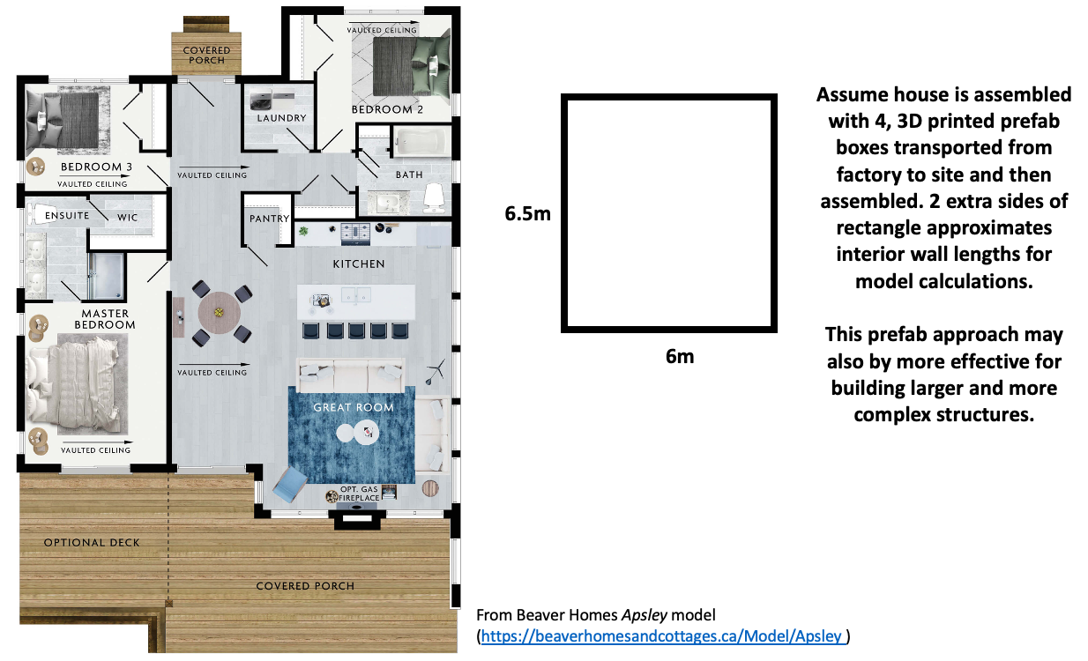

# Some questions to consider

1. Are the assumptions reasonable in your opinion?
2. What model assumptions would you make to allow us to predict the build times for neighbourhood configurations that blend row housing or low-rise apartments?
3. If you want to improve the model, what are some of the details or additional factors that you would consider that would have a true practical benefit in predicting project time?
4. What are the advantages and disadvantages of the spreadsheet based model development over other engineering computing environments such as Python or MATLAB?

Submission Instructions

1. Upload a *.**PDF** copy of the Wk-5 - Asynchronous Design Studio 5 Worksheet to the Avenue Dropbox titled **Asynchronous Design Studio Week 5** by Friday, Feb 11th, end of day (5:30pm)
   * Use the following naming convention: **macID_AsynchDS5.pdf**